**Create a virtual network with 2 subnets. Each subnet should have 16 Ips only.**

1.Open Azure Portal and Select Virtual Networks.

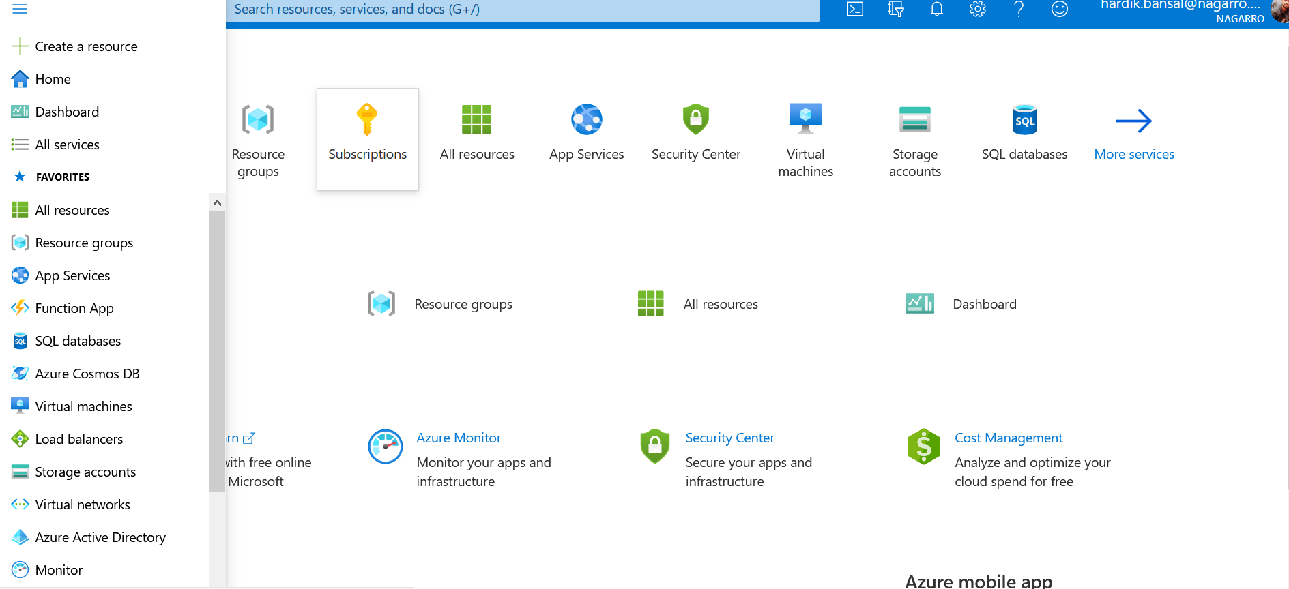

2. Select the Resource Group and Give Name to the Virtual Network.

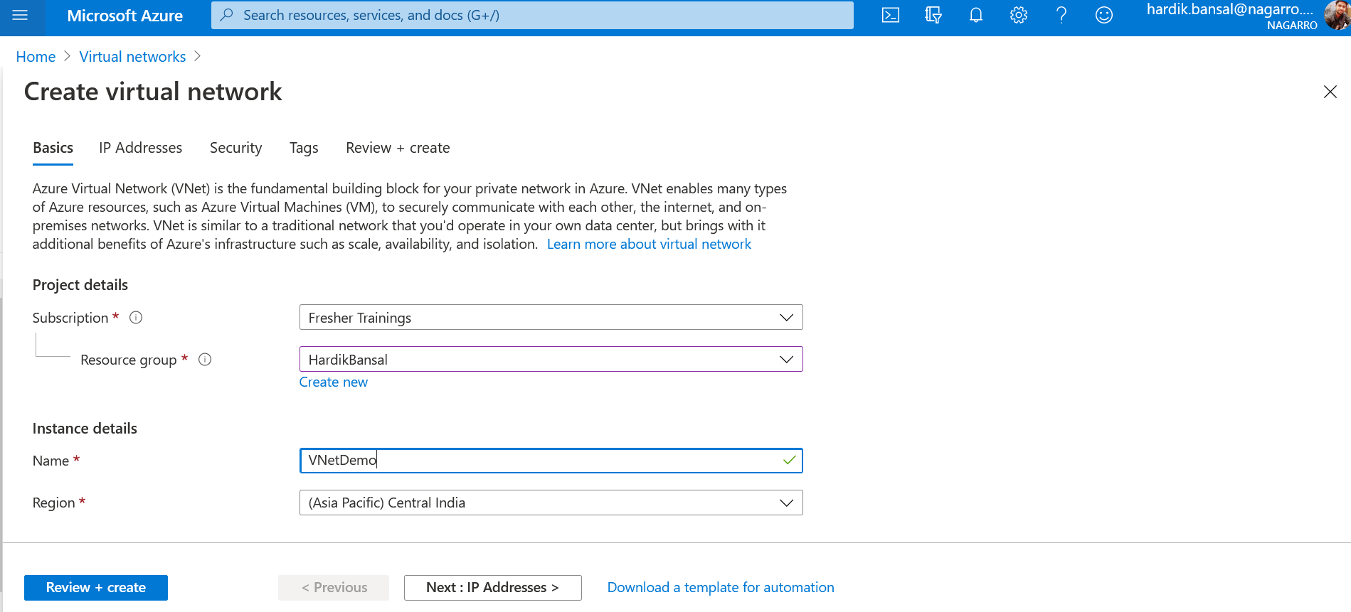

3.Add Subnet1 to the Virtual Network and Take 16 IP Address

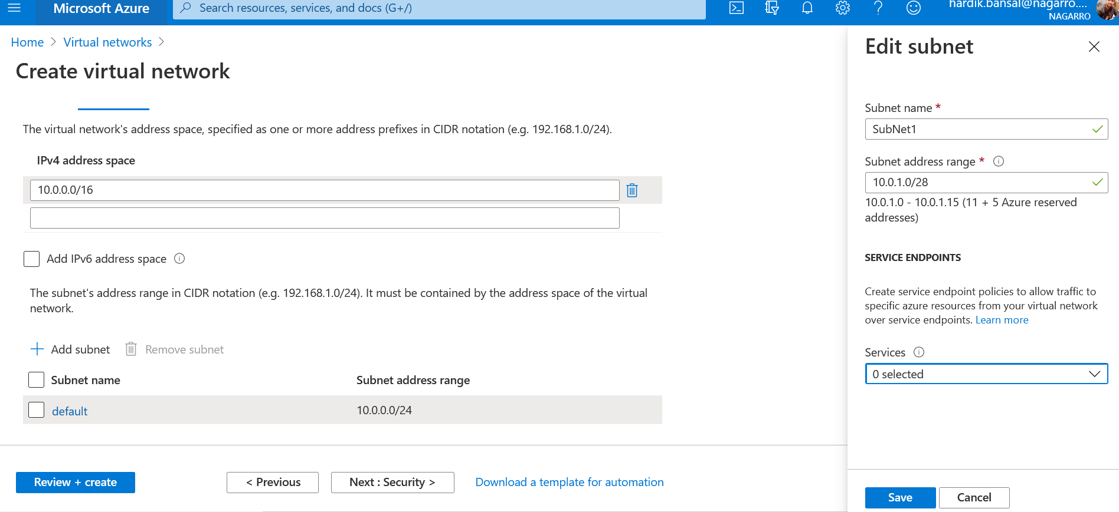

4.Add Subnet2 to the Virtual Network and Take 16 IP Address

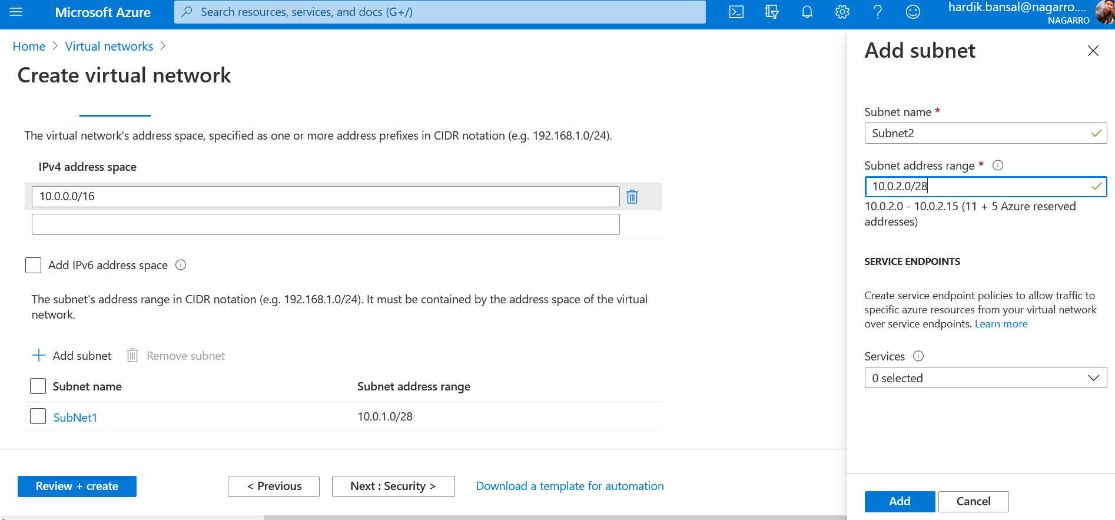

5. Select Review and Create and Shows Validation Passed Then Virtual Network is Validated and Then Select Create

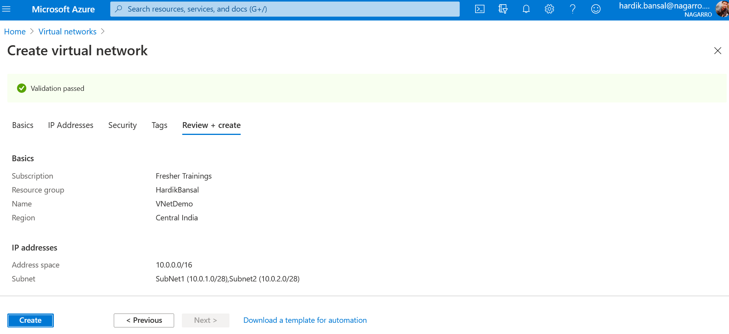

6.Virtual Network is deployed

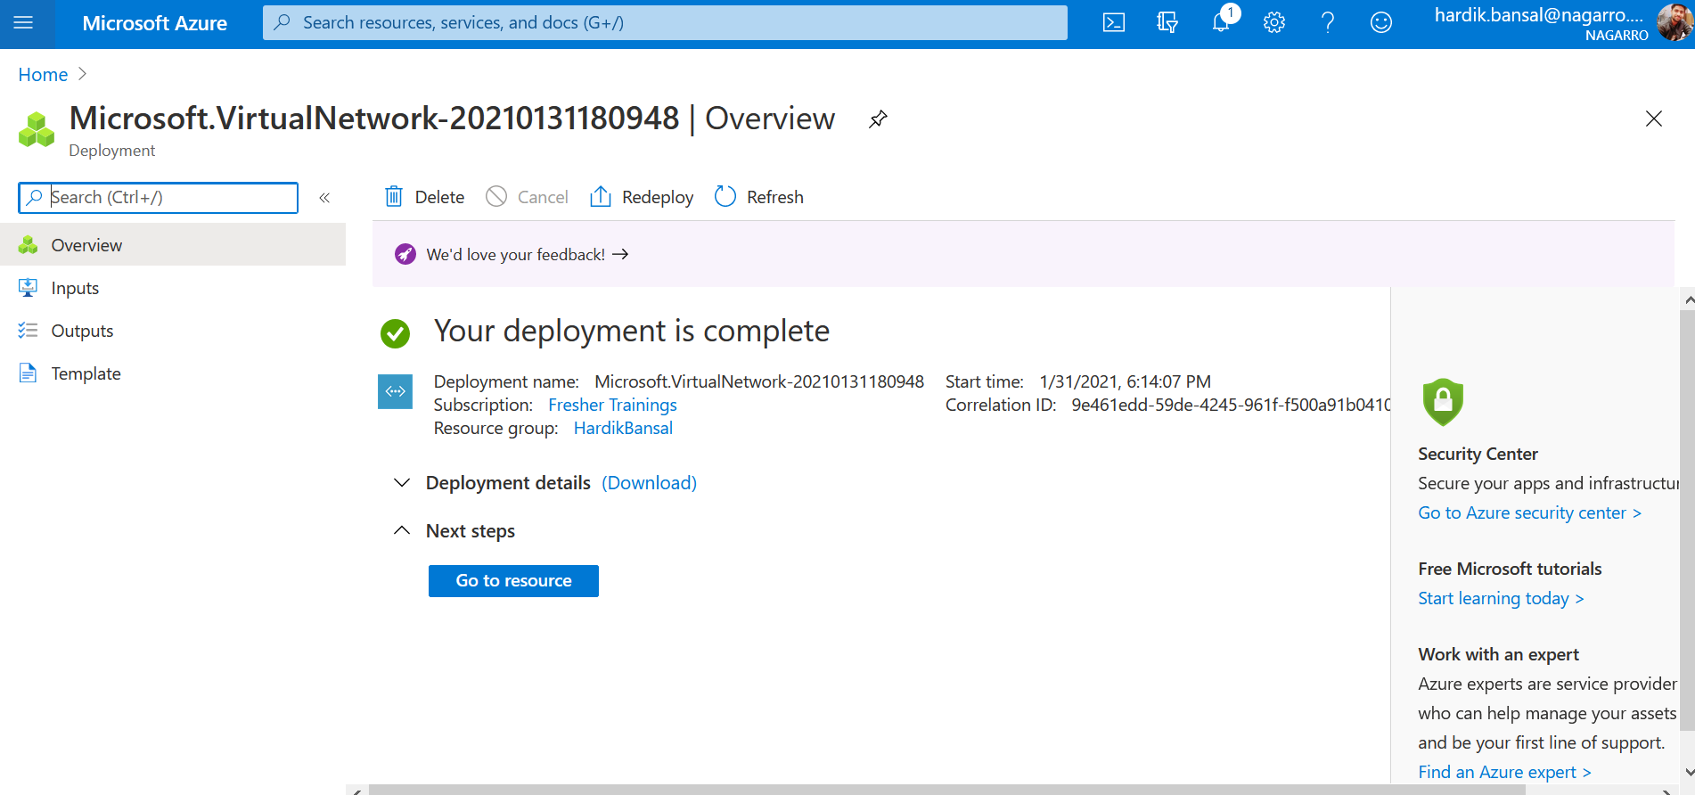

7. Check The Virtual Network Overview and Subnets.

